MEAL PLANNER

A Project report
Submitted in partial fulfilment of the Requirements for the award of the Degree of
BACHELOR OF SCIENCE (INFORMATION TECHNOLOGY)
By

Mr. Vinit Jella - 4539460
Mr. Sandeep Kumawat - 4497002

Under the esteemed guidance of
Ms. Saba Shaikh

DEPARTMENT OF INFORMATION TECHNOLOGY

B. K. BIRLA COLLEGE, KALYAN
(EMPOWERED AUTONOMOUS STATUS)
(Affiliated to University of Mumbai)
KALYAN, 421301 MAHARASHTRA 2025-2026

B. K. BIRLA COLLEGE, KALYAN
(EMPOWERED AUTONOMOUS STATUS)
(Affiliated to University of Mumbai)
KALYAN, 421301 MAHARASHTRA

DEPARTMENT OF INFORMATION TECHNOLOGY

CERTIFICATE
This is to certify that the project entitled, "Meal Planner", is Bonafide work of Mr. Sandeep Kumavat and Mr. Vinit Jella bearing Seat. No. 4497002, 4539460 submitted in partial fulfilment of the requirements for the award of degree of BACHELOR OF SCIENCE in INFORMATION TECHNOLOGY from the University of Mumbai.

Internal Guide Coordinator

External Examiner

Date: College seal

MEAL PLANNER

PRN No: 2023016400756967, 2023016400759424 Roll no: 4539460, 4497002

- Name of the Student(s)
Vinit Jella , Sandeep Kumawat
- Title of the Project
MEAL PLANNER
- Name of the Guide
Ms. Saba Sayyad
- Is this your First submission? Yes  No

Signature of the Student(s) Signature of the Guide

Signature of the Coordinator

Date:

Abstract

The Meal Planner is a modern web-based application designed to automate and simplify ingredient and meal planning operations. It eliminates the need for manually tracking ingredients, monitoring usage and scheduling replenishments. Built with a React frontend and Node.js backend, the system offers an intuitive user interface for staff and administrators to manage products, suppliers, and stock levels efficiently. The integration of MongoDB as a database ensures fast, reliable, and scalable data storage for real-time inventory tracking.

A key highlight of this project is the implementation of Google Authentication for secure login and user management. This integration provides a seamless and secure sign-in process using Google accounts, eliminating the need for manual credential handling and enhancing system reliability. Users can access personalized dashboards based on their roles—admin, manager, or staff—and perform operations in accordance with their privileges. This ensures that sensitive operations such as order approvals, limit configurations, and automation management remain restricted to authorized users only.

Another innovative component of this system is the Automation Module, which monitors inventory every hour and automatically places replenishment orders for items that fall below the defined reorder level. The automation intelligently validates each order against preset order limits, ensuring that no excess or invalid orders are placed. If any order exceeds the defined threshold, it is marked as failed and logged for review. This automation reduces human intervention, prevents stockouts, and maintains optimal inventory levels, making the system a complete and intelligent solution for modern grocery management.

ACKNOWLEDGEMENT

In the journey towards success, dedication, hard work, patience, and expert guidance serves as the fundamental pillars of our efforts. Our college, B.K. Birla College (Autonomous), has provided a nurturing environment for learning and growth.

We express our gratitude to Ms. Saba Sayyad, whose meticulous guidance and attention to detail have been invaluable. We extend our gratitude to everyone who has supported us, collectively transforming aspirations into tangible achievements, and illuminating the path forward.

DECLARATION

I hereby declare that the project entitled, “MEAL PLANNER” done at Kalyan, has not been in any case duplicated to submit to any other university for the award of any degree. To the best of my knowledge other than me, no one has submitted to any other university.

The project is done in partial fulfilment of the requirements for the award of the Degree of BACHELOR OF SCIENCE (INFORMATION TECHNOLOGY) to be submitted as final semester project as part of our curriculum.

Vinit Jella Sandeep Kumawat

TABLE OF CONTENTS
Chapter 1…………………………………………………..…………………………...9
Introduction………………………………………………………………………..…9
1.1 Background…………………………………………………………………...9
1.2 Objectives……………………………………………………………..………10
1.3 Purpose, Scope and Applicability……………………………………….……..11
1.3.1 Purpose………………………………………………………………………......11
1.3.2 Scope…………………………………………………………………………..11
1.3.3 Applicability ………………………………………………………….11

Chapter 2…………………………………………………………………………….12
System Analysis……………………………………………………………………..12
2.1 Existing System……………………………………………………………….12
2.2 Proposed System…………………………........................................................13
2.3 System Requirements……………………………………………………….....13
2.3.1 Functional Requirements…………………………………………………………14
2.3.2 Nonfunctional Requirements…………………………………………………......15
2.3.3 Technical Requirements………………………………………………………....15
2.3.4 Deployment and Maintenance…………………………………….........................15
2.4 Hardware Requirements………………………………………...……………..15
2.5 Software Requirements ………………………………………........................15-18
2.6 Justification of Selection of Technology 19
2.6.1 MERN Stack 19
2.6.2 Render 19
2.6.3 Literature Review 20
2.6.4 Why MERN Stack?.......................................................................................21
2.6.5 Why Render? 22

Chapter 3: System Design ……………………………………………………..23
3.1 System Architecture …………………………………………………...…….23-24

Chapter 4: Implementation Testing ………………………………………….…..25
4.1 Codes...………………………………………………………………………25-43
4.2 Testing Approach……………………………………………………..............44
4.2.1 Unit Testing………………………………………………………………44
4.2.2 Integration Testing………………………………………………………...45

Chapter 5: Results and Discussions ………………………………………...……...46

Chapter 6: Conclusions and Future Work……........................................................52

References ………………………………………………………………………...…53

TABLE OF FIGURES
Fig 1: System architecture 20
Fig 2: Login Page………………………………………………………………..46
Fig 3: Meal Dashboard……………………………………………………………...47
Fig 4: Product List …………….………………………………………………………..49
Fig 5: meal List…………………..…………………………………………………….49

Fig 5: Add / Update Product Form 50
Fig 6: Melas Entry / fooding Form…………………………………………………..50

Fig 7: Analytics………………………………………………………………….51

Chapter 1

Introduction
Meal Planner plays a vital role in the smooth functioning of any grocery store. It involves keeping track of all products, their quantities, expiry dates, and replenishment schedules. Traditionally, grocery stores have relied on manual methods for managing stock, which are time-consuming and prone to errors. Manual recording often leads to difficulties in tracking inventory levels accurately, overstocking or understocking of items, and inefficient handling of sales and purchases. With the growing demand for efficiency and accuracy in retail operations, there is a need for a computerized system that can manage inventory effectively and reduce human errors.
The Meal Planner is designed to automate the process of tracking and managing store products. It allows the store owner or staff to maintain a real-time record of all stock items, monitor sales, and generate reports for better decision-making. The system also helps in maintaining product information, managing suppliers, and streamlining billing processes. By implementing this system, grocery stores can save time, reduce wastage, improve customer satisfaction, and enhance overall productivity. This project ensures that inventory is well-organized and efficiently managed, which is crucial for the profitability and growth of the business.

Background
Meal stores handle a large number of products daily, including vegetables, fruits, packaged foods, and household items. Managing such a vast inventory manually is challenging and often leads to mistakes such as stock misplacement, overstocking, or shortage of essential items. Traditional methods of ingredient management require manual recording in registers, which is time-consuming and inefficient. Moreover, tracking sales, generating reports, and maintaining supplier information become difficult without a computerized system. With the advancement of technology, automating these processes has become essential to ensure accuracy, save time, and maintain smooth operations.

Objectives

The main objectives of the Meal Planner are:
- To maintain a real-time record of all products in the store.
- To reduce human errors in stock management and billing.
- To generate accurate reports for sales, purchases, and stock levels for better decision-making.
- To streamline the process of adding, updating, and removing products from inventory.
- To manage supplier details and maintain efficient purchase tracking.
- To monitor product expiry dates and prevent wastage of perishable items.
- To assist in forecasting demand based on historical sales data.
To improve overall operational efficiency, save time, and enhance customer
satisfaction.

Purpose, Scope, and Applicability

1.3.1 Purpose
The purpose of this project is to develop a computerized system that simplifies Meal Planning store. It aims to automate routine tasks, provide accurate stock information, and improve overall efficiency. The system helps store staff quickly access product details, track sales, and manage purchases without manual effort. By reducing human errors, it ensures smoother daily operations and better control over inventory. Moreover, it provides a centralized platform where managers can view all inventory-related activities at a glance, making supervision and decision-making much easier. The system also contributes to faster customer service by reducing billing time and avoiding stock-related delays.

1.3.2 Scope
The system covers all aspects of inventory management including product tracking, stock updates, sales recording, purchase management, and report generation. It can be used in small to medium-sized grocery stores and is scalable for future expansion. Additionally, it supports monitoring of product expiry dates, generating alerts for low stock, and assisting in planning purchases to meet customer demand effectively. The system also enables store owners to analyze sales patterns, manage seasonal inventory changes, and forecast future requirements. With these capabilities, it ensures that the store maintains an optimal stock level, reduces wastage, and improves overall operational efficiency.

1.3.3 Applicability
This system is applicable for grocery stores, supermarkets, and retail outlets where efficient meal planning is required. It is useful for store owners, managers, and staff to reduce manual work, prevent stock-outs, and maintain accurate records of products and sales. It also aids in decision-making by providing real-time data and reports, which can improve overall business performance and customer satisfaction. Furthermore, it can be used to train new staff in meal planning procedures quickly, ensuring consistency in operations. The system is adaptable for different store sizes and can integrate with other business tools, making it suitable for long-term growth and modernization.

Chapter 2

System Analysis

Existing System
In most grocery stores, the existing system of planning meal is still manual and traditional. Storekeepers usually maintain stock details, sales, and purchase records using registers, notebooks, or simple spreadsheets. Every time a customer buys something, the quantity is manually reduced from the stock record, and when new goods arrive, they are manually added to the list. This process requires constant attention and accuracy from the store staff. When the number of products is large, handling these records becomes time-consuming and difficult. Searching for specific product information, checking availability, or calculating total stock often takes extra time and effort. In some stores, daily sales and purchase summaries are written at the end of the day, which delays updates and can lead to confusion in tracking the actual inventory levels.
Another major drawback of the existing manual system is the lack of real-time data. The store owner cannot instantly know which items are running low or which ones are overstocked. Manual methods also make it difficult to identify expired or near-expiry products, which often leads to financial loss. There is no automated alert system to notify the staff about low stock or expiry dates. In addition, maintaining supplier details and purchase records manually can lead to misplaced data or incomplete information. Human errors such as wrong entries, miscalculations, or skipped updates are common and can affect the overall accuracy of the inventory.
The absence of automation also impacts the decision-making process. For example, if a store owner wants to analyze which items sell the most or which season has higher demand, they need to manually go through old records, which is tedious and inefficient. Generating reports or summaries from handwritten records becomes a lengthy task, especially when the business grows and the number of transactions increases. As a result, the existing system is slow, error-prone, and unable to support the fast-paced environment of a modern grocery store.

Proposed System
The proposed meal planner is designed to overcome all the problems of the manual system by providing a computerized and automated solution. This system helps in maintaining accurate and real-time information about the stock of items available in the store. It allows the user to easily add new products, update product details, and remove outdated or expired items from the database. Each time a product is sold or purchased, the stock quantity is automatically updated, reducing the chances of human error. The system also generates alerts for low stock or nearing expiry products, ensuring that the store never runs out of essential items. It simplifies day-to-day operations and helps store owners save time and effort while maintaining better control over inventory.
In addition to basic stock management, the proposed system also includes features like sales and purchase tracking, supplier management, and report generation. It can create daily, weekly, and monthly reports that help the store owner analyze sales performance and make better business decisions. The system has a user-friendly interface that can be operated easily by anyone with basic computer knowledge. Since all records are stored digitally, the chances of data loss are minimal, and accuracy is ensured. Overall, the proposed system provides faster processing, better accuracy, and improved efficiency, making it a reliable tool for modern grocery store operations.

System Requirements

2.3.1 Functional Requirements:
  - User Management

  - Performance Metrics

  - Feedback Process

  - Reporting

  - Notification

  - Integration

2.3.2 Nonfunctional Requirements:
  - Performance

  - Scalability

  - Security

  - Usability

  - Reliability

  - Maintainability

  - Compatibility

2.3.3 Technical Requirements:
  - Database Stack

  - Protein tools

  - Testing

2.3.4 Deployment and Maintenance:
  - Deployment Plan

  - Maintenance Plan

Hardware Requirements

- Processor: Intel Core i3 or higher
- RAM: Minimum 4 GB (8 GB recommended for smooth performance)
- Hard Disk: At least 250 GB storage space
- Monitor: 15-inch LED or higher resolution display
- Keyboard: Standard 104-key keyboard
- Mouse: Optical mouse
- Printer: Barcode or billing printer (for receipts and reports)
- Scanner: Barcode scanner (for product identification)
- Network: Stable internet or LAN connection (for database access)
- UPS: Power backup to prevent data loss

Software Requirements

Operating System:
• Development: Windows 10 / Windows 11
• Deployment: Linux (Docker containerized) / Windows Server / Cloud Platform (AWS, Azure, Google Cloud)

Development Tools:
• Code Editor: Visual Studio Code (recommended) / Any modern IDE
• Version Control: Git
• Package Manager: npm (Node Package Manager) v6.0 or higher
• Container Platform: Docker & Docker Compose
• Runtime: Node.js v14.0 or higher (recommended: v18+)

Web Technologies:

Frontend:
- React.js v18.2.0
- React HTML1 (Client-side routing)
- React Icons v4.12.0 (UI icons)
- React Toastify v9.1.3 (Notifications)
- Recharts v2.8.0 (Data visualization)
- Styled Components v6.1.1 (CSS-in-JS)
- QR Code. react v3.2.0 (Barcode generation)
- Axios v1.6.2 (HTTP client)
- Socket.io-client v4.7.4 (Real-time communication)
Backend:
- Node.js (Runtime environment)
- Express.js v4.18.2 (Web framework)
- Socket.io v4.8.1 (WebSocket server)
Database:
- MongoDB v6.0 or higher
- Mongoose v8.0.3 (ODM - Object Data modelling)

APIs and Libraries:
Authentication:
- JSON Web Token (JWT) v9.0.2
- Passport.js v0.7.0
- Passport-JWT v4.0.1
- Passport-Google-OAuth20 v2.0.0
- bcryptjs v2.4.3 (Password hashing)
Middleware:
- CORS v2.8.5 (Cross-Origin Resource Sharing)
- Express-validator v7.0.1 (Input validation)
- Multer v1.4.5-lts.1 (File upload handling)
- HTTP-proxy-middleware v3.0.5 (Proxy setup)
Services & Utilities:
- Nodemailer v6.9.7 (Email notifications)
- Cron v3.1.6 (Scheduled tasks/automation)
- dotenv v16.3.1 (Environment configuration)
Deployment:
- Docker (Containerization)
- Docker Compose v3.8 (multi-container orchestration)
- Concurrently v8.2.2 (Run multiple commands)

Testing:
• Unit Testing: Jest (included in React Scripts v5.0.1)
• Integration Testing: React Testing Library v13.4.0
• API Testing: Axios-based custom test scripts (test-auth.js, test-inventory.js)
• User Event Testing: @testing-library/user-event v14.5.1
• DOM Testing: @testing-library/jest-dom v5.17.0

Development Utilities:
• Hot Reload: Nodemon v3.0.2 (Backend)
• Code Quality: ESLint v8.57.0
• Code Formatting: Prettier v3.2.5
• Build Tool: React Scripts v5.0.1 (Create React App)

Additional Requirements:
Email Service:
- SMTP Server (Gmail, SendGrid, or custom SMTP)
- Port: 587 (TLS) or 465 (SSL)
Network Ports:
- Frontend: 3000 (development)
- Backend: 5000 (API server)
- MongoDB: 27017
- Socket.io: Real-time on backend port

Browser Compatibility:
- Chrome (latest)
- Firefox (latest)
- Safari (latest)
- Edge (latest)

System Architecture:
- Pattern: MERN Stack (MongoDB, Express, React, Node.js)
- Authentication: JWT-based token authentication with Google OAuth 2.0
- Real-time: WebSocket (Socket.io) for live notifications
- Automation: Cron jobs for scheduled stock monitoring
- API: RESTful API architecture

Chapter 3

System Design
3.1 System Architecture
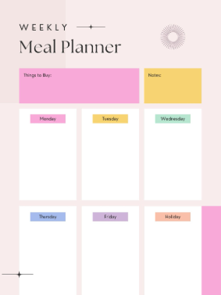

Fig 1: System Architecture

The data design for the project is structured to support three distinct user roles: faculty, admin, and student. Each role has access to specific functionalities that facilitate the appraisal process and ensure a seamless flow of data. This design ensures that the right data is accessible to the appropriate users.

Faculty Login
Faculty members log in via a secure page to manage lectures, start/stop attendance sessions, monitor live attendance, and view downloadable reports. The dashboard gives quick controls for session settings (OTP, location-radius), model status, and attendance analytics.
Data design components:
- Lecture Sessions: Records lecture metadata (title, date, start/end time, teacherId, session token, OTP/location constraints).
- Face Registration Status: Tracks which students have registered face data (boolean + descriptor refs) and allows management of registrations.
- Attendance Records: Stores per-student attendance entries (lectureId, studentId, timestamp, method, confidence) for reporting and audit.
- Attendance Reports: Aggregates attendance data per lecture, per student, and per class (percentages, present/absent/late counts) for viewing or export (CSV/PDF

Chapter 4 Implementation and Testing

Code
Index.html

<!DOCTYPE html>
<html lang="en">
<head>
<meta charset="UTF-8">
<meta name="viewport" content="width=device-width, initial-scale=1.0">
<title>Meal Planner - Plan Your Perfect Week</title>
<link rel="stylesheet" href="styles.css">
<link href="https://cdnjs.cloudflare.com/ajax/libs/font-awesome/6.0.0/css/all.min.css" rel="stylesheet">
</head>
<body>
<header class="header">
<div class="container">
<h1><i class="fas fa-utensils"></i> Meal Planner</h1>
<p>Plan your meals, save time, and eat better</p>
</div>
</header>

<nav class="navigation">
<div class="container">
<ul class="nav-menu">
<li><a href="#weekly-plan" class="nav-link active"><i class="fas fa-calendar-week"></i> Weekly Plan</a></li>
<li><a href="#meal-database" class="nav-link"><i class="fas fa-database"></i> Meal Database</a></li>
<li><a href="#nutrition-tracker" class="nav-link"><i class="fas fa-chart-line"></i> Nutrition</a></li>
<li><a href="#meal-prep" class="nav-link"><i class="fas fa-clock"></i> Meal Prep</a></li>
<li><a href="#grocery-stores" class="nav-link"><i class="fas fa-store"></i> Grocery Stores</a></li>
<li><a href="#meal-sharing" class="nav-link"><i class="fas fa-share-alt"></i> Share</a></li>
<li><a href="#dietary-filters" class="nav-link"><i class="fas fa-filter"></i> Dietary Filters</a></li>
<li><a href="#shopping-list" class="nav-link"><i class="fas fa-shopping-cart"></i> Shopping List</a></li>
<li><a href="#add-meal" class="nav-link"><i class="fas fa-plus"></i> Add Meal</a></li>
</ul>
</div>
</nav>

<main class="main-content">
<div class="container">
<!-- Weekly Plan Section -->
<section id="weekly-plan" class="section active">
<h2><i class="fas fa-calendar-week"></i> Weekly Meal Plan</h2>
<div class="week-grid">
<div class="day-card" data-day="Monday">
<h3>Monday</h3>
<div class="meals-container">
<div class="meal-slot breakfast">
<h4><i class="fas fa-sun"></i> Breakfast</h4>
<div class="meal-item" data-category="breakfast">
<span class="meal-name">Pancakes</span>
<button class="remove-meal" onclick="removeMeal('Monday', 'breakfast')"><i class="fas fa-times"></i></button>
</div>
</div>
<div class="meal-slot lunch">
<h4><i class="fas fa-sun"></i> Lunch</h4>
<div class="meal-item" data-category="lunch">
<span class="meal-name">Caesar Salad</span>
<i class="fab fa-pinterest"></i>
<span>Pinterest</span>
</a>
<a href="https://tiktok.com/@mealplanner" target="_blank" class="social-link tiktok" onclick="trackSocialClick('tiktok')">
<i class="fab fa-tiktok"></i>
<span>TikTok</span>
</a>
</div>
</div>
</div>

<div class="footer-bottom">
<p>&copy; 2024 Meal Planner. Plan your meals, save time, and eat better!</p>
<div class="footer-links">
<a href="#privacy">Privacy Policy</a>
<a href="#terms">Terms of Service</a>
<a href="#contact">Contact Us</a>
</div>
</div>
</div>
</footer>

<!-- Floating Social Media Widget -->
<div class="floating-social" id="floating-social">
<div class="social-toggle" onclick="toggleFloatingSocial()">
<i class="fas fa-share-alt"></i>
</div>
<div class="social-menu" id="social-menu">
<a href="https://instagram.com/mealplanner" target="_blank" class="floating-social-link instagram" onclick="trackSocialClick('instagram')">
<i class="fab fa-instagram"></i>
</a>
<a href="https://wa.me/1234567890" target="_blank" class="floating-social-link whatsapp" onclick="trackSocialClick('whatsapp')">
<i class="fab fa-whatsapp"></i>
</a>
<a href="https://t.me/mealplanner" target="_blank" class="floating-social-link telegram" onclick="trackSocialClick('telegram')">
<i class="fab fa-telegram"></i>
</a>
<a href="https://facebook.com/mealplanner" target="_blank" class="floating-social-link facebook" onclick="trackSocialClick('facebook')">
<i class="fab fa-facebook"></i>
</a>
<a href="https://twitter.com/mealplanner" target="_blank" class="floating-social-link twitter" onclick="trackSocialClick('twitter')">
<i class="fab fa-twitter"></i>
</a>
</div>
</div>

<script src="script.js"></script>
</body>
</html>

Script.js

// Meal Planner JavaScript
class MealPlanner {
constructor() {
this.weeklyPlan = {
Monday: { breakfast: null, lunch: null, dinner: null },
Tuesday: { breakfast: null, lunch: null, dinner: null },
Wednesday: { breakfast: null, lunch: null, dinner: null },
Thursday: { breakfast: null, lunch: null, dinner: null },
Friday: { breakfast: null, lunch: null, dinner: null },
Saturday: { breakfast: null, lunch: null, dinner: null },
Sunday: { breakfast: null, lunch: null, dinner: null }
};

this.mealDatabase = {
breakfast: [
{ name: "Pancakes", prepTime: 15, ingredients: ["flour", "eggs", "milk", "butter"], calories: 350, protein: 12, carbs: 45, fat: 12, dietary: ["vegetarian"] },
{ name: "Oatmeal", prepTime: 10, ingredients: ["oats", "milk", "honey", "berries"], calories: 280, protein: 8, carbs: 52, fat: 6, dietary: ["vegetarian", "gluten-free"] },
{ name: "Scrambled Eggs", prepTime: 8, ingredients: ["eggs", "butter", "salt", "pepper"], calories: 200, protein: 14, carbs: 2, fat: 15, dietary: ["vegetarian", "keto", "low-carb"] },
{ name: "Avocado Toast", prepTime: 12, ingredients: ["bread", "avocado", "lemon", "salt"], calories: 320, protein: 8, carbs: 35, fat: 18, dietary: ["vegetarian", "vegan"] }
],
lunch: [
{ name: "Caesar Salad", prepTime: 20, ingredients: ["lettuce", "parmesan", "croutons", "caesar dressing"], calories: 320, protein: 15, carbs: 18, fat: 22, dietary: ["vegetarian", "low-carb"] },
{ name: "Chicken Sandwich", prepTime: 25, ingredients: ["bread", "chicken", "lettuce", "tomato", "mayo"], calories: 450, protein: 28, carbs: 35, fat: 22, dietary: ["high-protein"] },
{ name: "Vegetable Soup", prepTime: 30, ingredients: ["carrots", "celery", "onions", "vegetable broth"], calories: 180, protein: 6, carbs: 32, fat: 4, dietary: ["vegetarian", "vegan", "low-fat"] },
Style.css
* {
margin: 0;
padding: 0;
box-sizing: border-box;
}

body {
font-family: 'Segoe UI', Tahoma, Geneva, Verdana, sans-serif;
line-height: 1.6;
color: #333;
background: linear-gradient(135deg, #ffb366 0%, #ff8c42 100%);
min-height: 100vh;
}

.container {
max-width: 1200px;
margin: 0 auto;
padding: 0 20px;
}

/* Header Styles */
.header {
background: rgba(255, 255, 255, 0.95);
backdrop-filter: blur(10px);
box-shadow: 0 2px 20px rgba(0, 0, 0, 0.1);
padding: 2rem 0;
text-align: center;
}

.header h1 {
font-size: 3rem;
color: #4a5568;
margin-bottom: 0.5rem;
.social-links {
display: grid;
grid-template-columns: repeat(2, 1fr);
gap: 0.75rem;
}

Database schema sql

CREATE TABLE IF NOT EXISTS users (
user_id INTEGER PRIMARY KEY AUTOINCREMENT,
username VARCHAR(50) UNIQUE NOT NULL,
email VARCHAR(100) UNIQUE NOT NULL,
password_hash VARCHAR(255) NOT NULL,
first_name VARCHAR(50),
last_name VARCHAR(50),
created_at DATETIME DEFAULT CURRENT_TIMESTAMP,
updated_at DATETIME DEFAULT CURRENT_TIMESTAMP,
is_active BOOLEAN DEFAULT 1
);

-- Dietary preferences table
CREATE TABLE IF NOT EXISTS dietary_preferences (
preference_id INTEGER PRIMARY KEY AUTOINCREMENT,
preference_name VARCHAR(50) UNIQUE NOT NULL,
description TEXT,
created_at DATETIME DEFAULT CURRENT_TIMESTAMP
);

-- User dietary preferences junction table
CREATE TABLE IF NOT EXISTS user_dietary_preferences (
user_id INTEGER,
preference_id INTEGER,
PRIMARY KEY (user_id, preference_id),
FOREIGN KEY (user_id) REFERENCES users(user_id) ON DELETE CASCADE,
FOREIGN KEY (preference_id) REFERENCES dietary_preferences(preference_id) ON DELETE CASCADE
);

-- Meal categories table
CREATE TABLE IF NOT EXISTS meal_categories (
category_id INTEGER PRIMARY KEY AUTOINCREMENT,
category_name VARCHAR(50) UNIQUE NOT NULL,
description TEXT,
created_at DATETIME DEFAULT CURRENT_TIMESTAMP
);

-- Meals table to store meal information
CREATE TABLE IF NOT EXISTS meals (
meal_id INTEGER PRIMARY KEY AUTOINCREMENT,
meal_name VARCHAR(100) NOT NULL,
category_id INTEGER NOT NULL,
prep_time INTEGER NOT NULL DEFAULT 0,
calories INTEGER DEFAULT 0,
protein DECIMAL(5,2) DEFAULT 0,
carbs DECIMAL(5,2) DEFAULT 0,
fat DECIMAL(5,2) DEFAULT 0,
fiber DECIMAL(5,2) DEFAULT 0,
sugar DECIMAL(5,2) DEFAULT 0,
sodium DECIMAL(5,2) DEFAULT 0,
description TEXT,
instructions TEXT,
image_url VARCHAR(255),
created_by INTEGER,
created_at DATETIME DEFAULT CURRENT_TIMESTAMP,
updated_at DATETIME DEFAULT CURRENT_TIMESTAMP,
is_active BOOLEAN DEFAULT 1,
FOREIGN KEY (category_id) REFERENCES meal_categories(category_id),
FOREIGN KEY (created_by) REFERENCES users(user_id),
UNIQUE(meal_name, category_id)
);

-- Ingredients table
CREATE TABLE IF NOT EXISTS ingredients (
ingredient_id INTEGER PRIMARY KEY AUTOINCREMENT,
ingredient_name VARCHAR(100) UNIQUE NOT NULL,
category VARCHAR(50), -- e.g., 'vegetable', 'protein', 'grain', 'dairy'
unit VARCHAR(20) DEFAULT 'pieces', -- e.g., 'cups', 'grams', 'pieces'
calories_per_unit DECIMAL(8,2) DEFAULT 0,
protein_per_unit DECIMAL(8,2) DEFAULT 0,
carbs_per_unit DECIMAL(8,2) DEFAULT 0,
fat_per_unit DECIMAL(8,2) DEFAULT 0,
created_at DATETIME DEFAULT CURRENT_TIMESTAMP
);

Chapter 5

Results and Discussions

Main Page
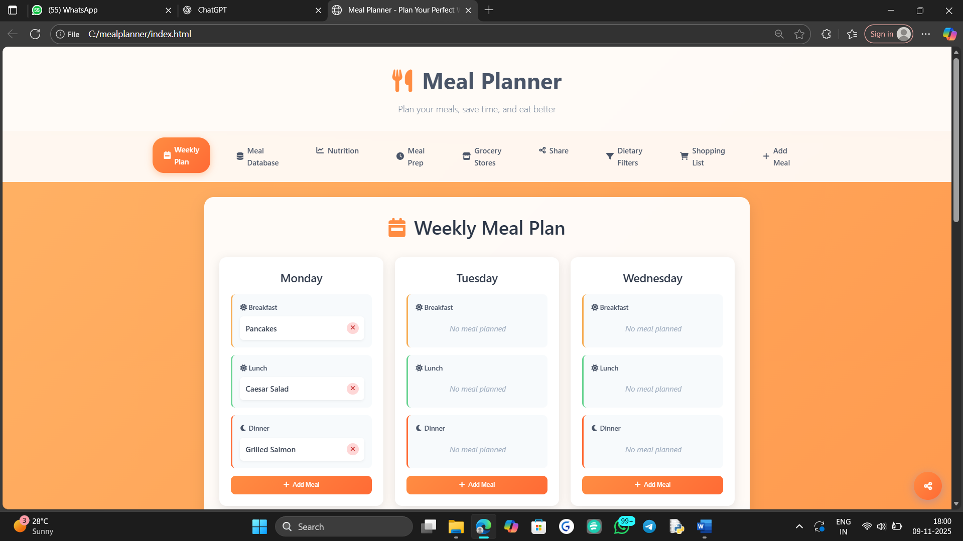
Fig 2: Login Page

Functionality of the main Page
The main Page serves as the main entry point to the Face Recognitionmeal planner System. It provides users with secure access to their respective dashboards based on their assigned roles — shold adult, or Admin. The design is clean, user-friendly, and responsive, offering quick navigation between Login and Register tabs.
The Login Section contains two input fields: Email or Username and Password. Users enter their credentials, which are securely validated against stored records in the database. Passwords are protected through encryption and hashing techniques to ensure privacy and security. If a user forgets their credentials, a “Forgot Password/Username” option allows account recovery through a secure verification process.

Meal Database
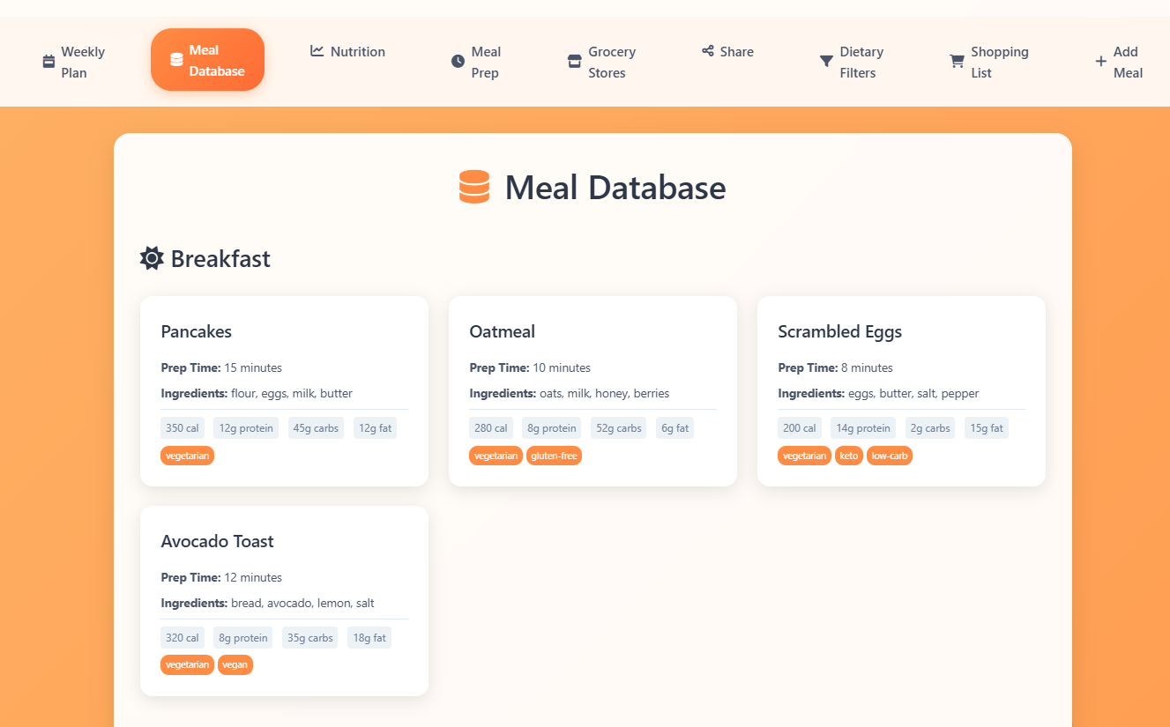

Fig 5: Meal Database

Database Functionality in "Storage System"
The Meal Dashboard in the Face Recognition Attendance System provides a centralized interface for people to manage meal, monitor meal, track database progress, and handle assignments efficiently. Once logged in, faculty members are greeted with a personalized dashboard displaying key academic metrics such as Total vitamin, Total meals, and AverageProtein.
Key Functionalities:
- Meal Management:
Faculty members can view all their scheduled lectures in the “My Lectures” section. Each lecture card displays details such as lecture name, date, time, and short description. Teachers can also create new lectures using the “Create Lecture” button.
- Session Control):
The dashboard allows faculty to start and stop attendance sessions directly from the interface. When a session is started, the system generates a unique OTP that must be shared with students. Attendance can only be marked if students are within the specified geolocation distance and enter the valid OTP, ensuring both accuracy and fairness.
Attendance Overview:
The dashboard provides real-time statistics showing the total number of

Nutrition Tracker
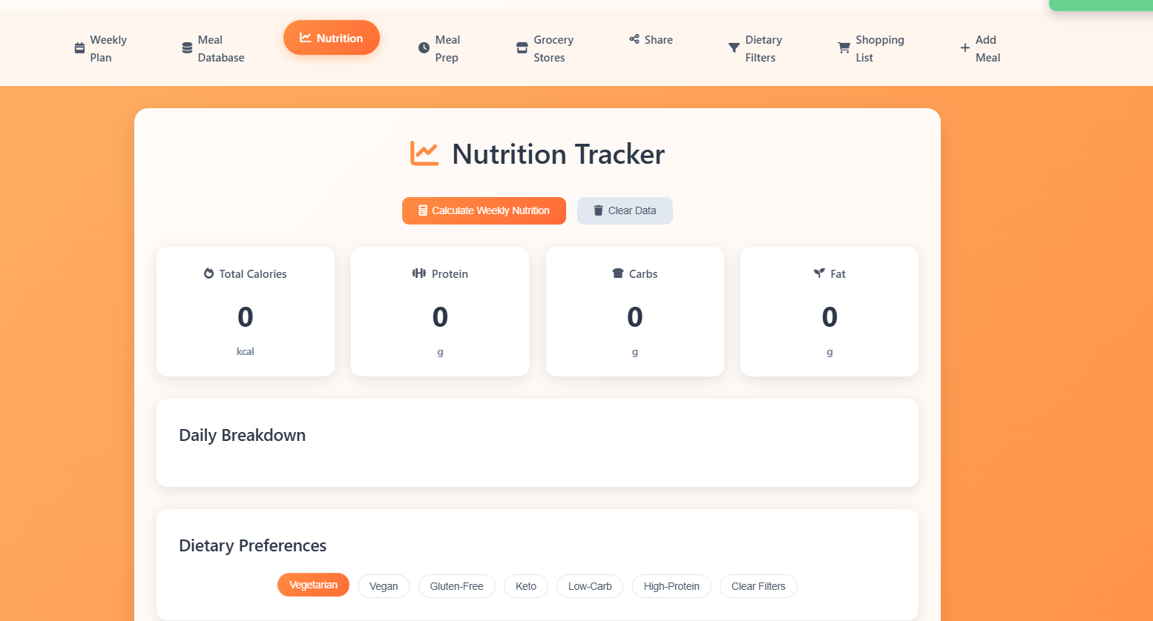
Fig 7: Nutrition tracker

Nutirtion tracker Functionality in "tracker System”

The meal Dashboard in the Face Recognition Attendance System provides students with a simple and secure interface to manage their academic activities and monitor preparation records. Once a student logs in, the system displays key indicators such as meals Attended, My Attendance Percentage, and Upcomingmeals.
Key Functionalities
- Preparation time for melas to eat in time diet and maintain Marking
Students can mark their attendance through real-time face recognition once the teacher starts a session. The system verifies the student’s identity using the camera feed and validates both OTP and location range before recording attendance.
- Available Lectures
The dashboard lists all upcoming or scheduled lectures in the “Available Lectures” section. Each lecture card shows details such as lecture title, faculty name, date, time, and description. If the session has not yet begun, the interface displays the status “Session Not Started”, prompting the student to wait until the faculty initiates the session.

Meal Preparation Scheduler

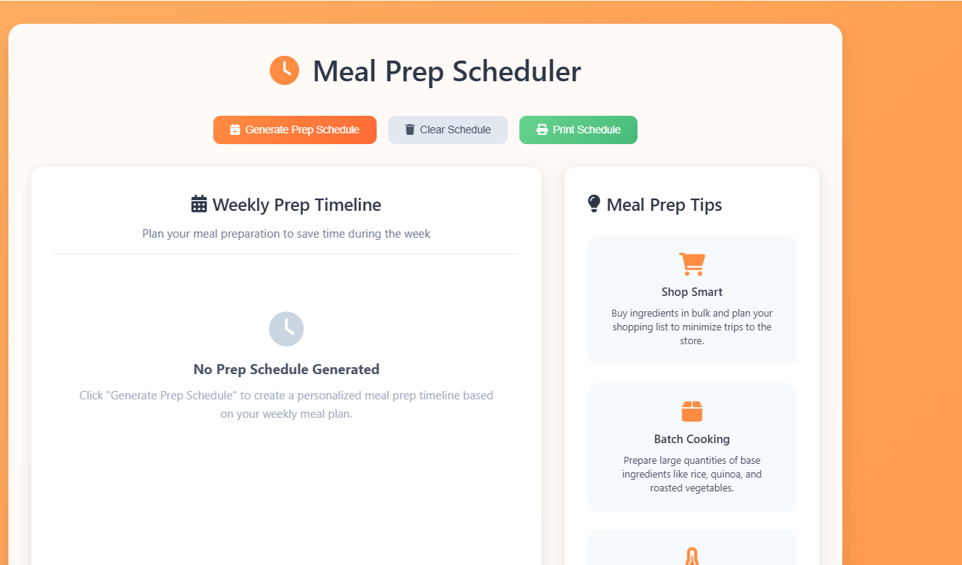
The Syllabus & meal Management module in the Face Recognition Attendance System enables faculty members to plan, monitor, and manage the progress of subjects and their associated syllabus topics. This section ensures organized tracking of teaching activities, allowing teachers to record completed portions and manage pending topics effectively.
Key Functionalities
Add New Meal:
Faculty members can easily create new mealusing the “Add New meal” button. Each subject includes essential details such as themealName, Semester, Academic Year, and Total Teaching Hours, ensuring accurate course tracking and scheduling.
Topic and Progress Tracking:
Each subject card displays the list of topics covered in the syllabus. Teachers can mark topics as completed once covered in lectures, which automatically updates the completion percentage shown on the progress bar. This helps visualize teaching progress at a glance and maintain up-to-date academic records.

Syllabus Details:
Grocery Store Integration

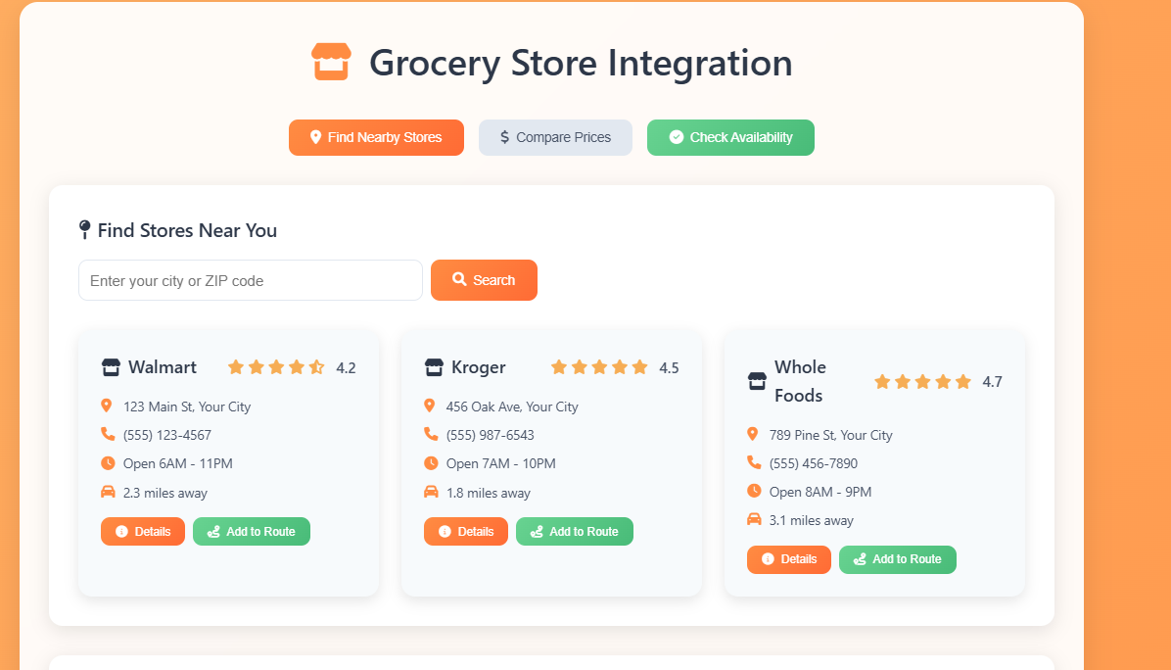

The Mark Attendance module is the most crucial component of the Face Recognition Attendance System It provides a secure and automated way for students to mark their attendance through face recognition, combined with OTP verification and geolocation validation to ensure accuracy and prevent fraudulent attendance.

Key Functionalities

mealand Face Capture:
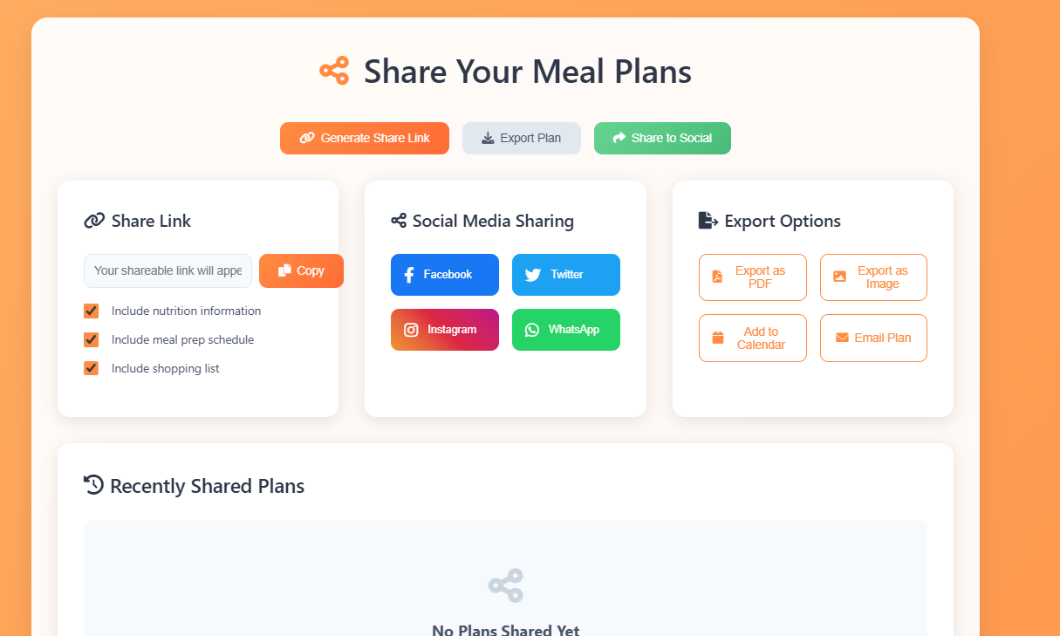

Chapter 6 Conclusions and Future Work
  - Conclusion

Conclusion:
The Meal Planner project has been a successful demonstration of how efficient and meaningful applications can be built using only front-end technologies including HTML, CSS, and JavaScript, without the need for any backend integration. This project fulfills its primary objective of offering users a convenient and structured way to plan their weekly meals, make healthier food decisions, and create better eating habits based on their preferences and lifestyle. Through its intuitive design, responsive layout, and smooth interaction flow, the system ensures that users of all age groups can easily navigate and utilize the features without technical difficulty. By storing meal plans locally in the browser, the application ensures complete data privacy and independence from internet connectivity, making it a fast, lightweight, and user-controlled solution. Development of this system helped in understanding front-end logic, DOM handling, local storage management, and user-centered interface design principles. The project also highlights how front-end-only systems still hold strong value in modern web development, especially in cases where simplicity, speed, and privacy are priorities. While this version focuses on fundamental meal planning, the project opens the door to numerous future enhancements such as nutritional calculators, recipe suggestions, shopping list automation, calorie tracking, AI-based meal recommendations, and cloud-based storage for multi-device access. In conclusion, this Meal Planner emphasizes healthy lifestyle management through technology and reflects how thoughtful design paired with fundamental coding concepts can lead to a practical real-world application. It stands as a strong base for further innovations, demonstrating that even without backend functionality, a web application can be powerful, effective, and highly relevant in everyday life.

Future Work
Although the current version of the Meal Planner successfully provides a simple and efficient platform for organizing meals using only HTML, CSS, and JavaScript, there are several opportunities to expand and enhance its capabilities in the future. One major enhancement could be the integration of a backend system and database to enable user accounts, cloud storage, and access to meal plans across multiple devices. Additionally, advanced nutritional features such as automatic calorie calculation, macronutrient breakdown, and access to verified food nutrition databases can significantly improve user experience and accuracy. The system can also be enhanced by including recipe suggestions, smart grocery list generation, and meal-based shopping reminders to support users in planning and shopping more efficiently. Implementing AI-based recommendation systems to suggest personalized meal plans based on dietary needs, fitness goals, or allergies would further enrich the application. A mobile app version or PWA (Progressive Web App) implementation would also help users access the planner conveniently on their smartphones. Finally, adding chart-based progress tracking, weekly health reports, voice input, and multilingual support can make the Meal Planner more powerful, user-friendly, and adaptable to a wider audience. These improvements will transform the system into an intelligent, interactive, and complete digital nutrition assistant.

Chapter 7 . References

- Node.js Documentation: https://youtu.be/ZLxOUw2ougo?si=3gZ_kGMq2z0_y9_c
- Meal Planner Documentation: https://youtu.be/NZtKqGx_TR4?si=4ozNVy_9b2XWuYD2
- MongoDB Documentation – https://www.mongodb.com/docs/

